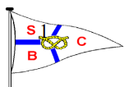
Stafford Boat Club

Supported Charities for 2023

For the Club’s Charity of 2023 it has been decided by Council that, following a number of suggestions, our efforts throughout 2023 will be shared between The Stafford Parkinson Support Group and Prostrate Cancer Support (MacMillan Urology Staffs), both are very close to our Club members’ hearts. The first, as one of our members has recently been diagnosed with Parkinson’s disease and the second in acknowledgement of support given to Alan Gossage prior to his sad passing last year.

